**SBM-20-1 End Cap Assembly Instructions**

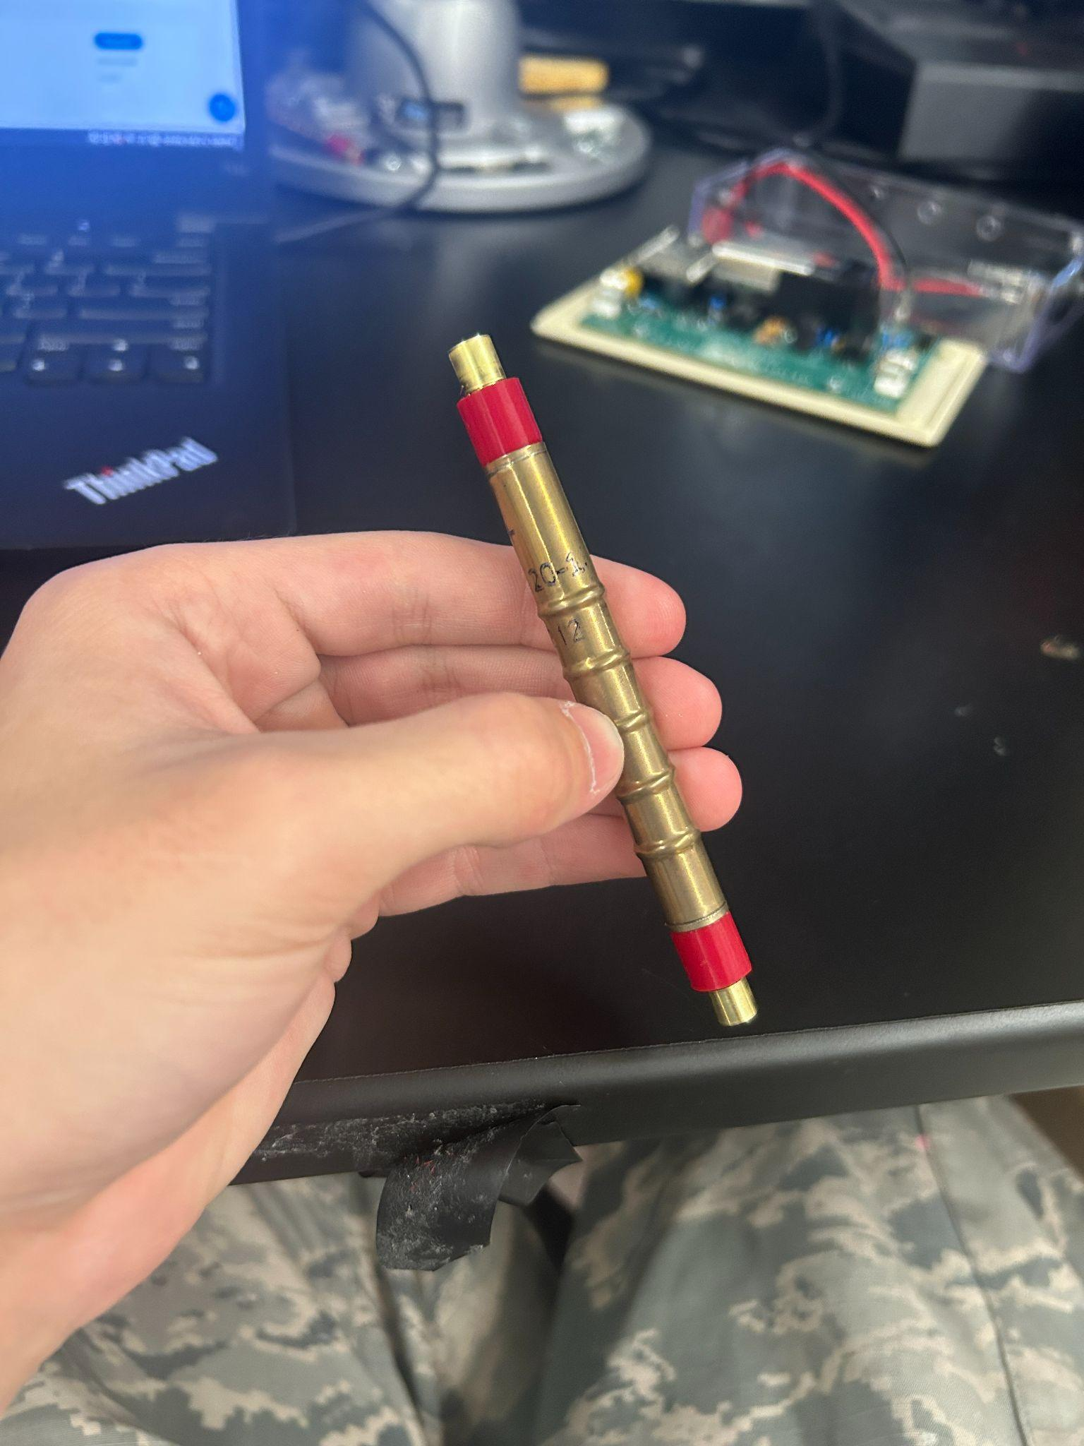

# **INTRODUCTION:**

This document shall serve as a quick and dirty guide on how to put ends on the SBM-20-1 with use of a 3d printer and brass tube

# **PARTS AND EQUIPMENT:**

* 3d printer (cheap ones are fine, this one I use was $112 from micro center)
* PLA+ True Red filament 1.75mm (other colors work fine too, but red matches the original)
* H62 1/4"(6.5mm) OD Brass Tube 0.5mm Wall × 300mm Length Brass Tubing Seamless Round Tubing
* Pliers
* Files and/or sand paper
* Tube cutter
* Small screwdriver/excess filament removal instrument

**STEP 1:**

Assuming you already have G-Code for the printer of your choice generated by some slicing software (ie. prusa slicer) print out the end and remove the bottom chaff that it’s printed with.

I usually use 100% infill with 0 support and it works well

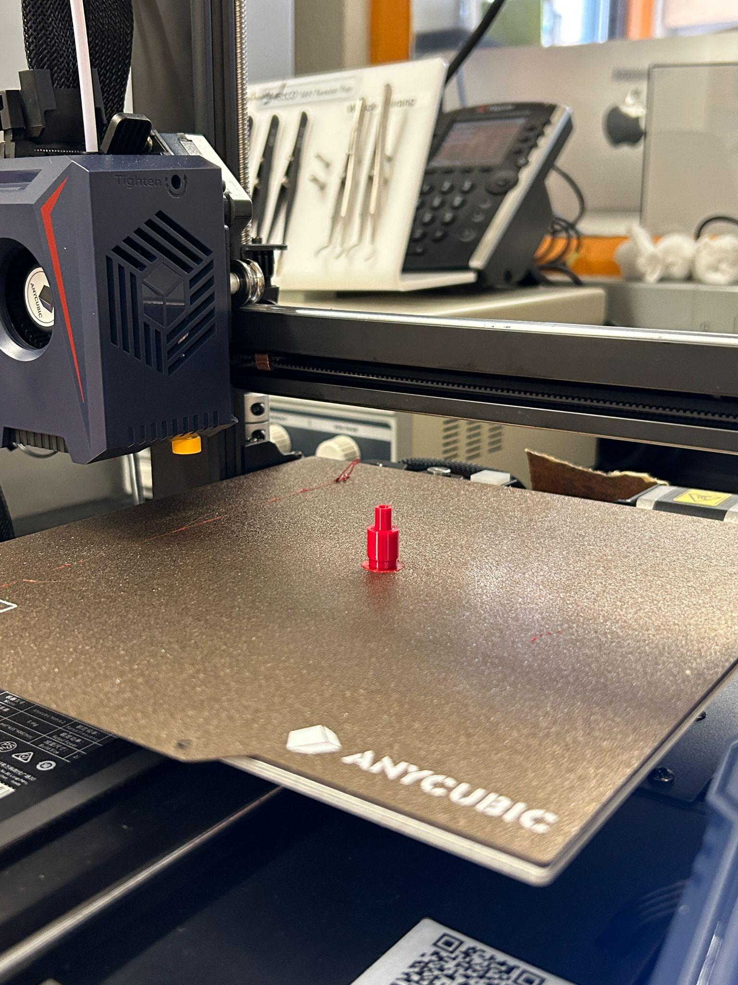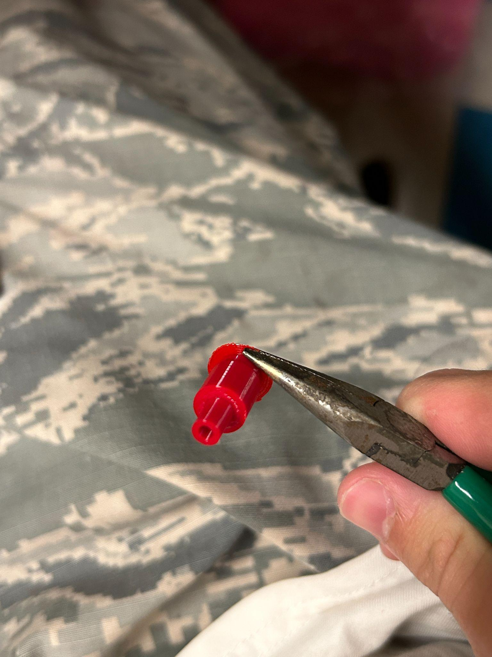

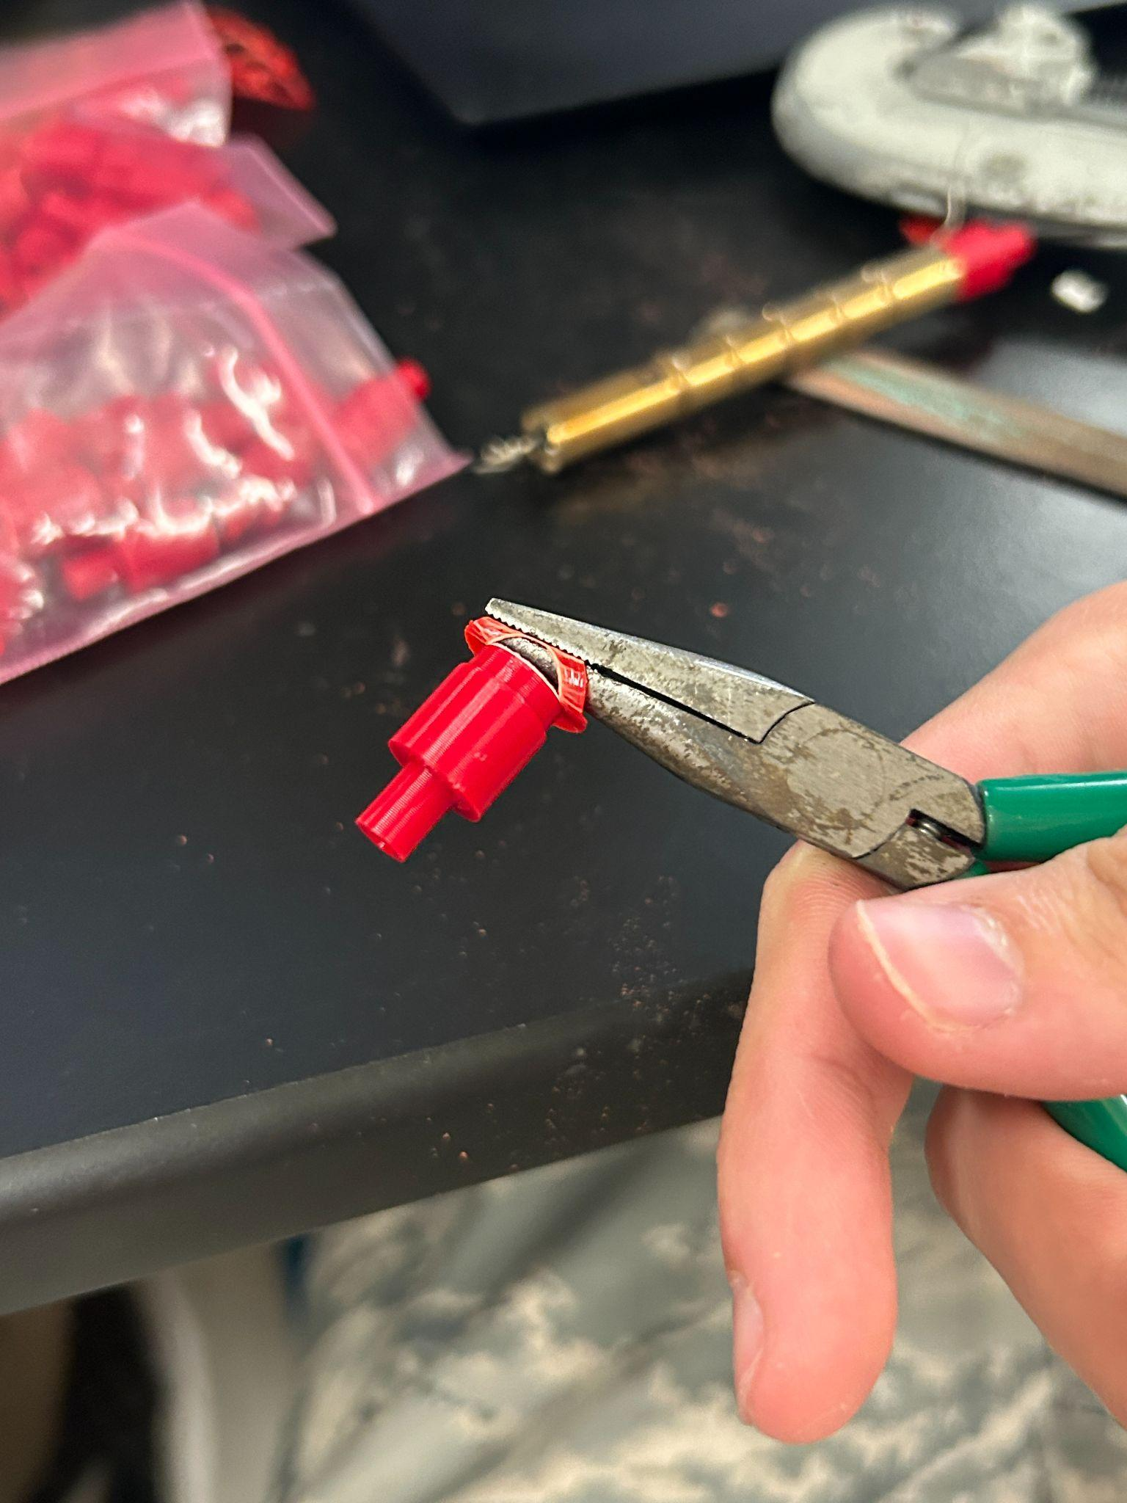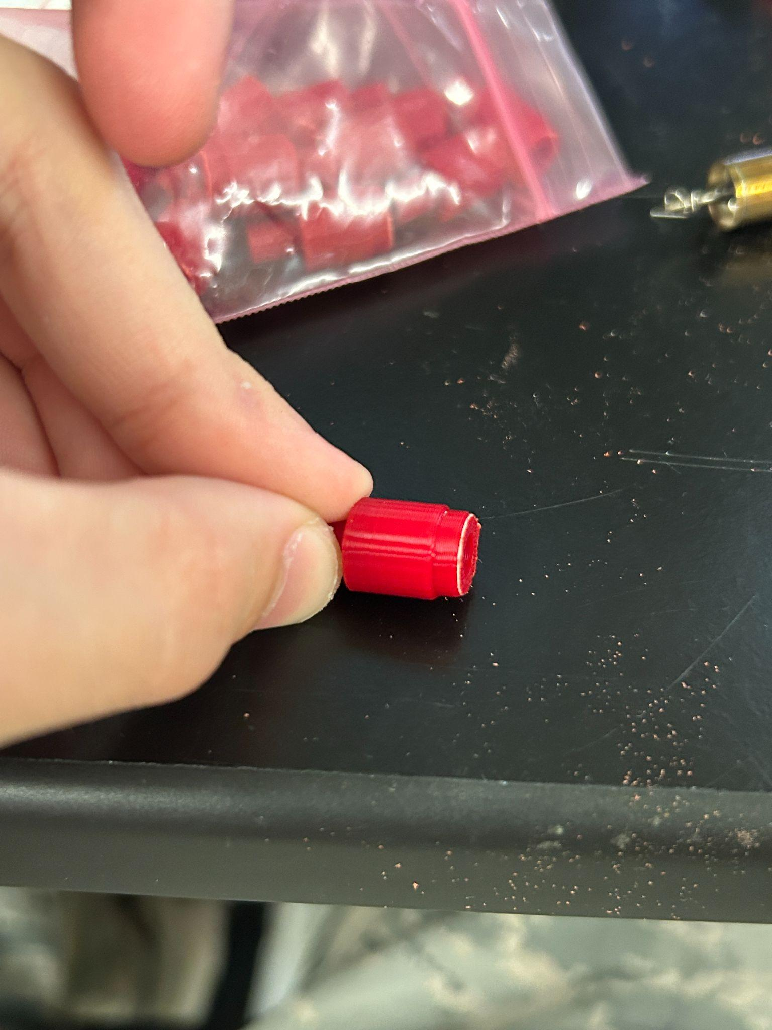

**STEP 2:**

You may notice a line that goes from the top of the end to the base (called the seam in 3d printing), to ensure more even fitment file it off

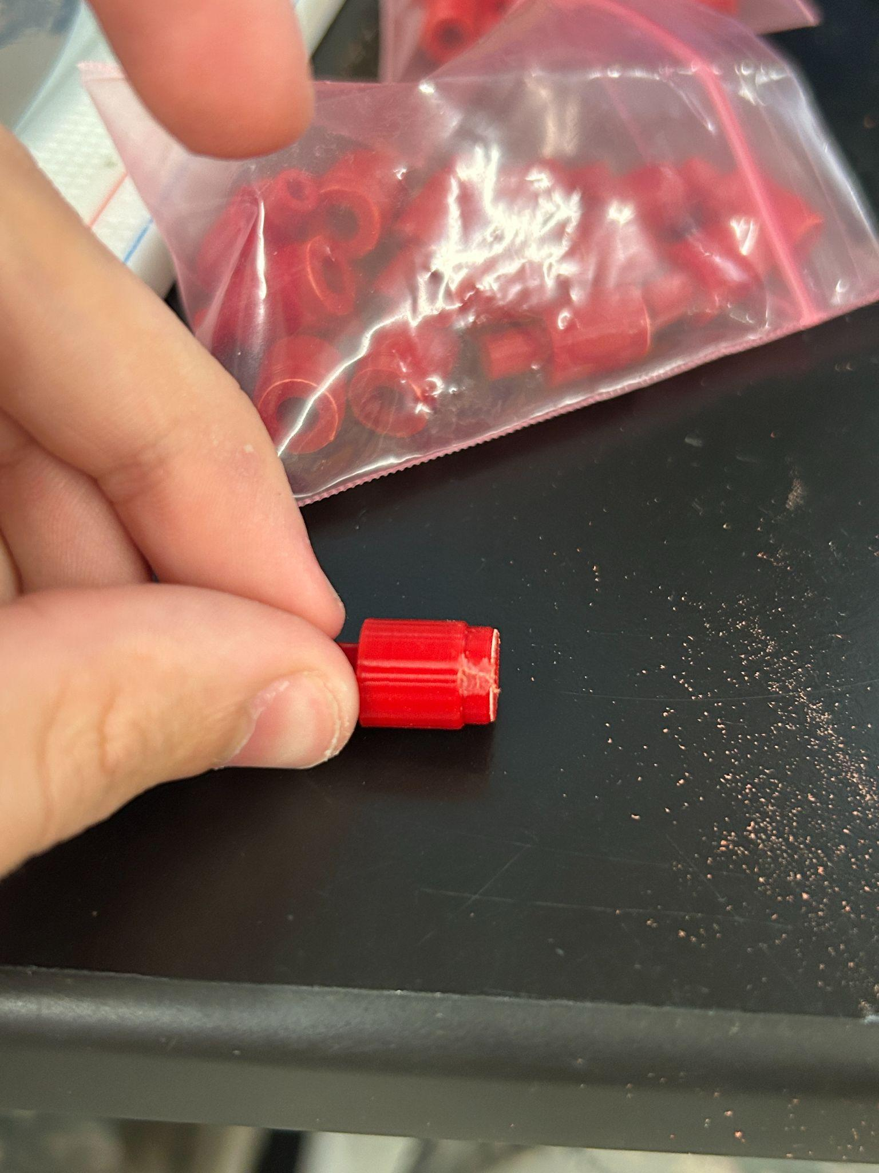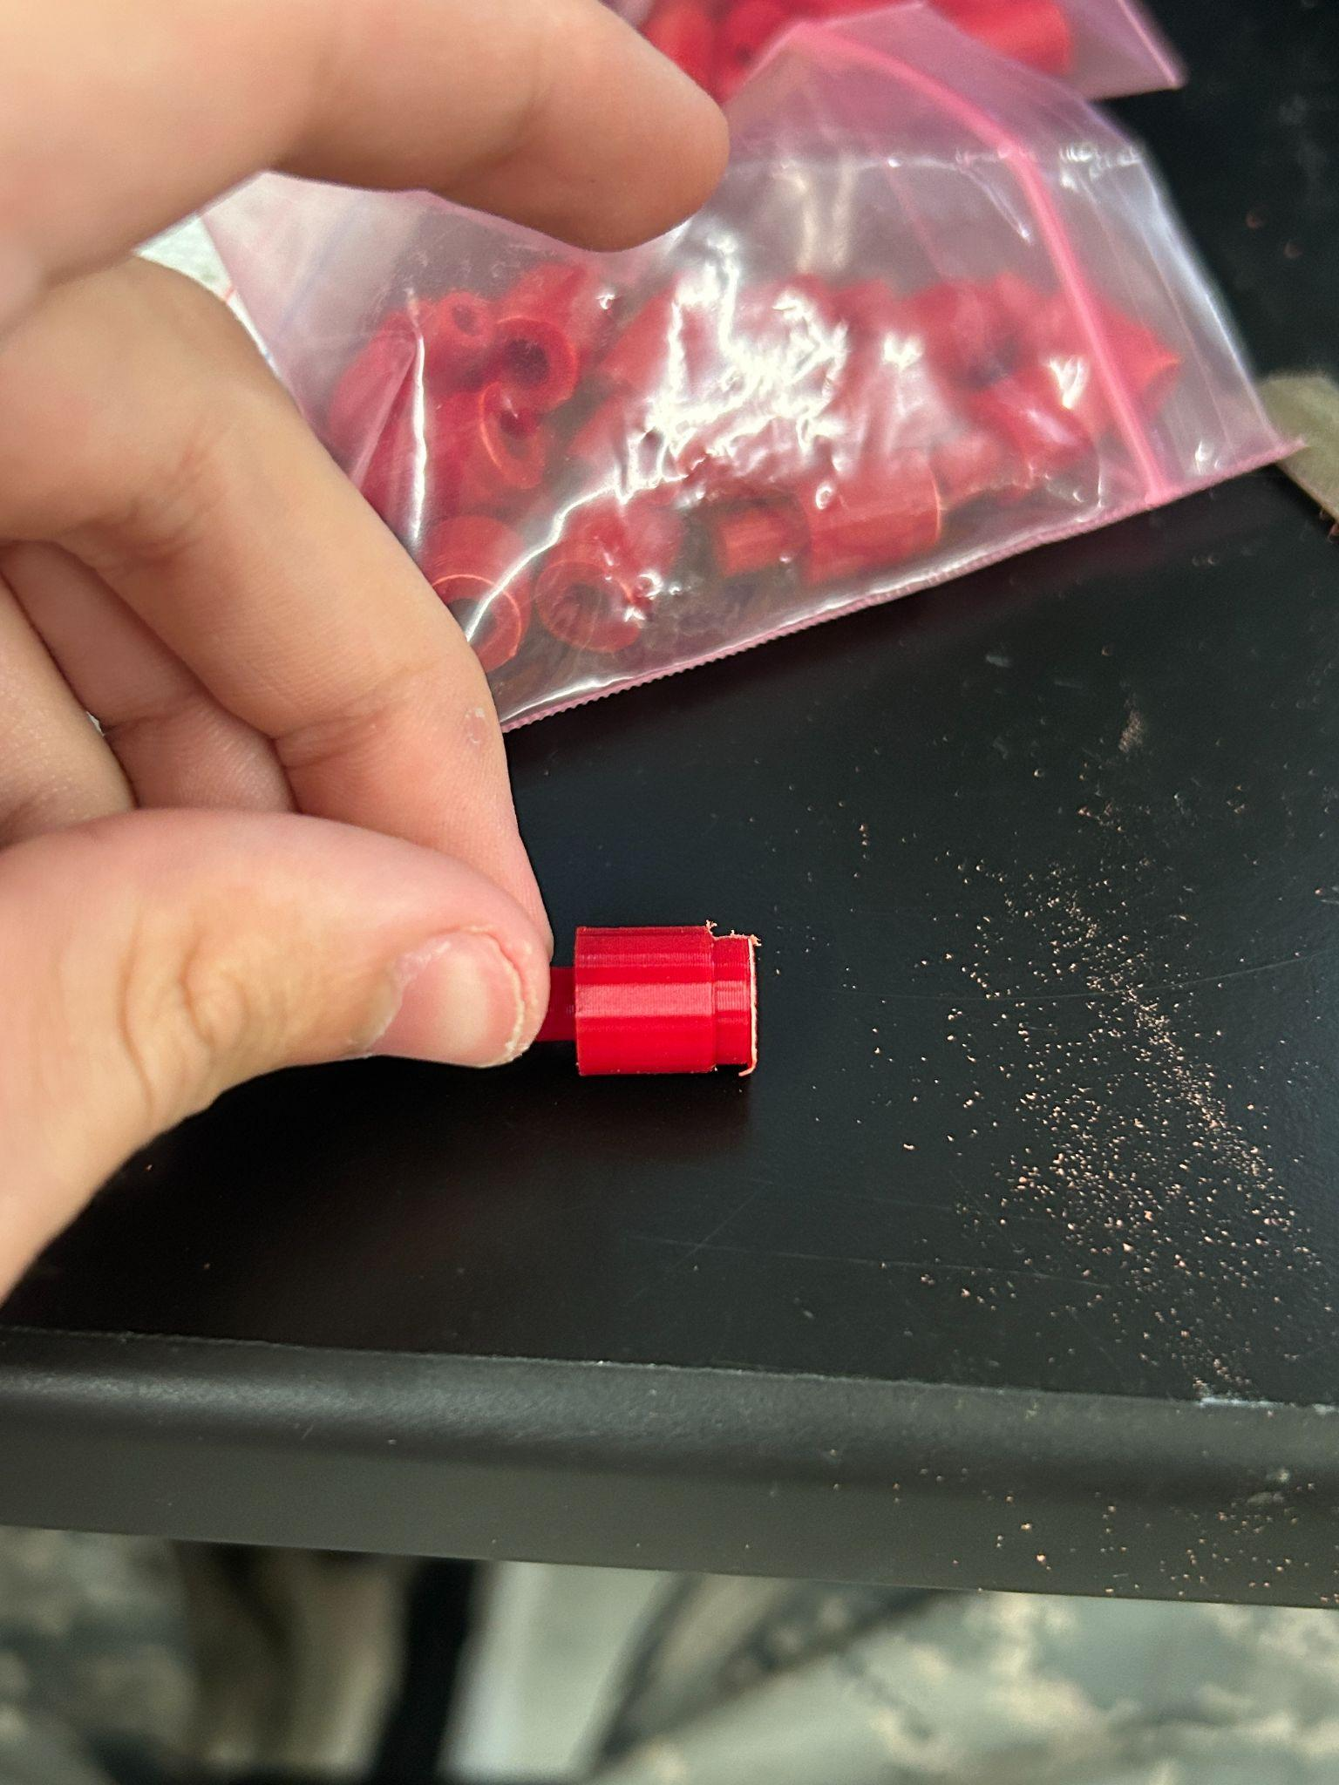

**STEP 3:**

File around the base of the end a bit to allow for easier fitment into the tube

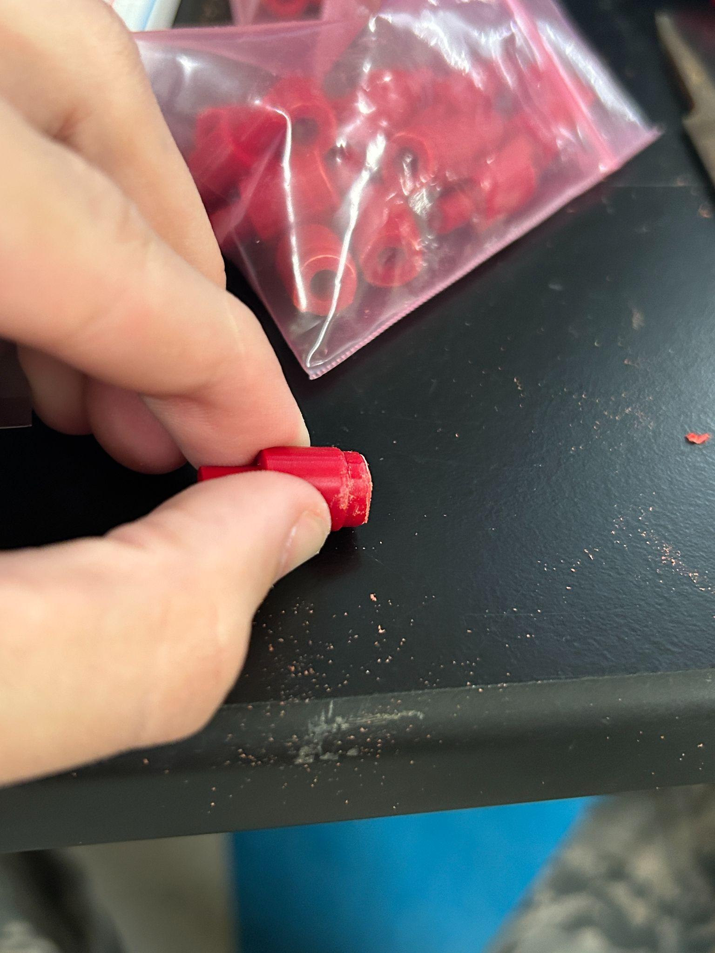

**STEP 4:**

Unwrap wire from ends of the geiger tube and starting on the negative (glass side) push the end cap loosely in and fully seat it with pliers. If you feel the end is too tight, shave off a bit more from the base

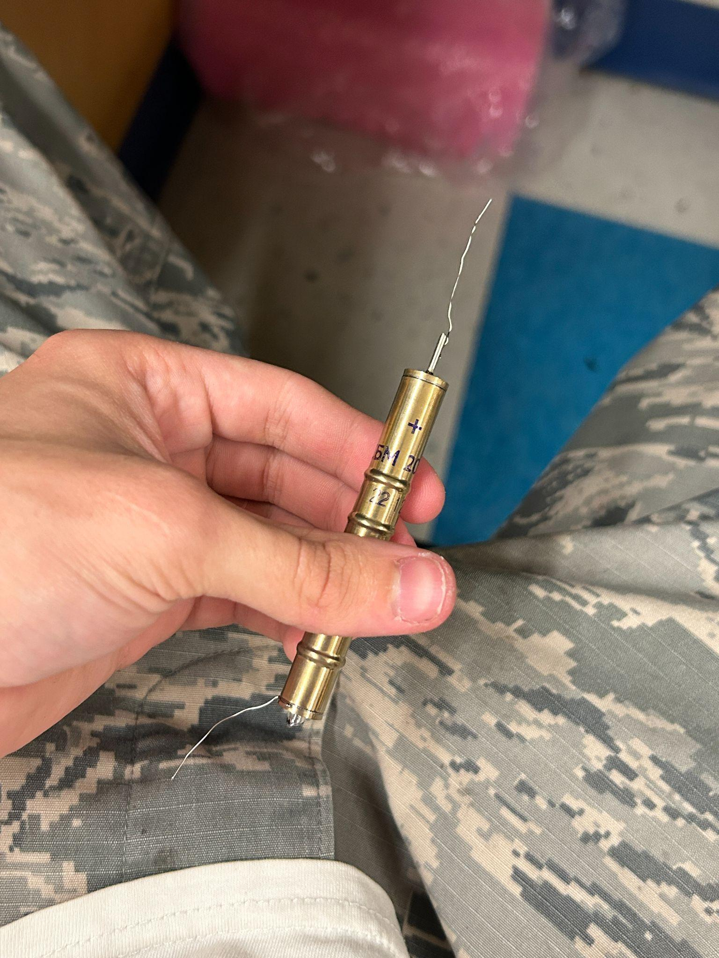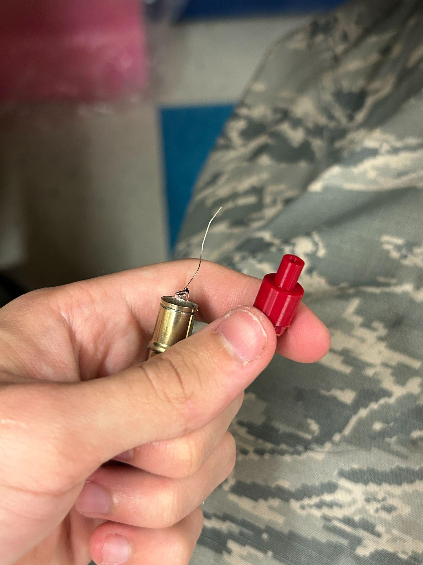

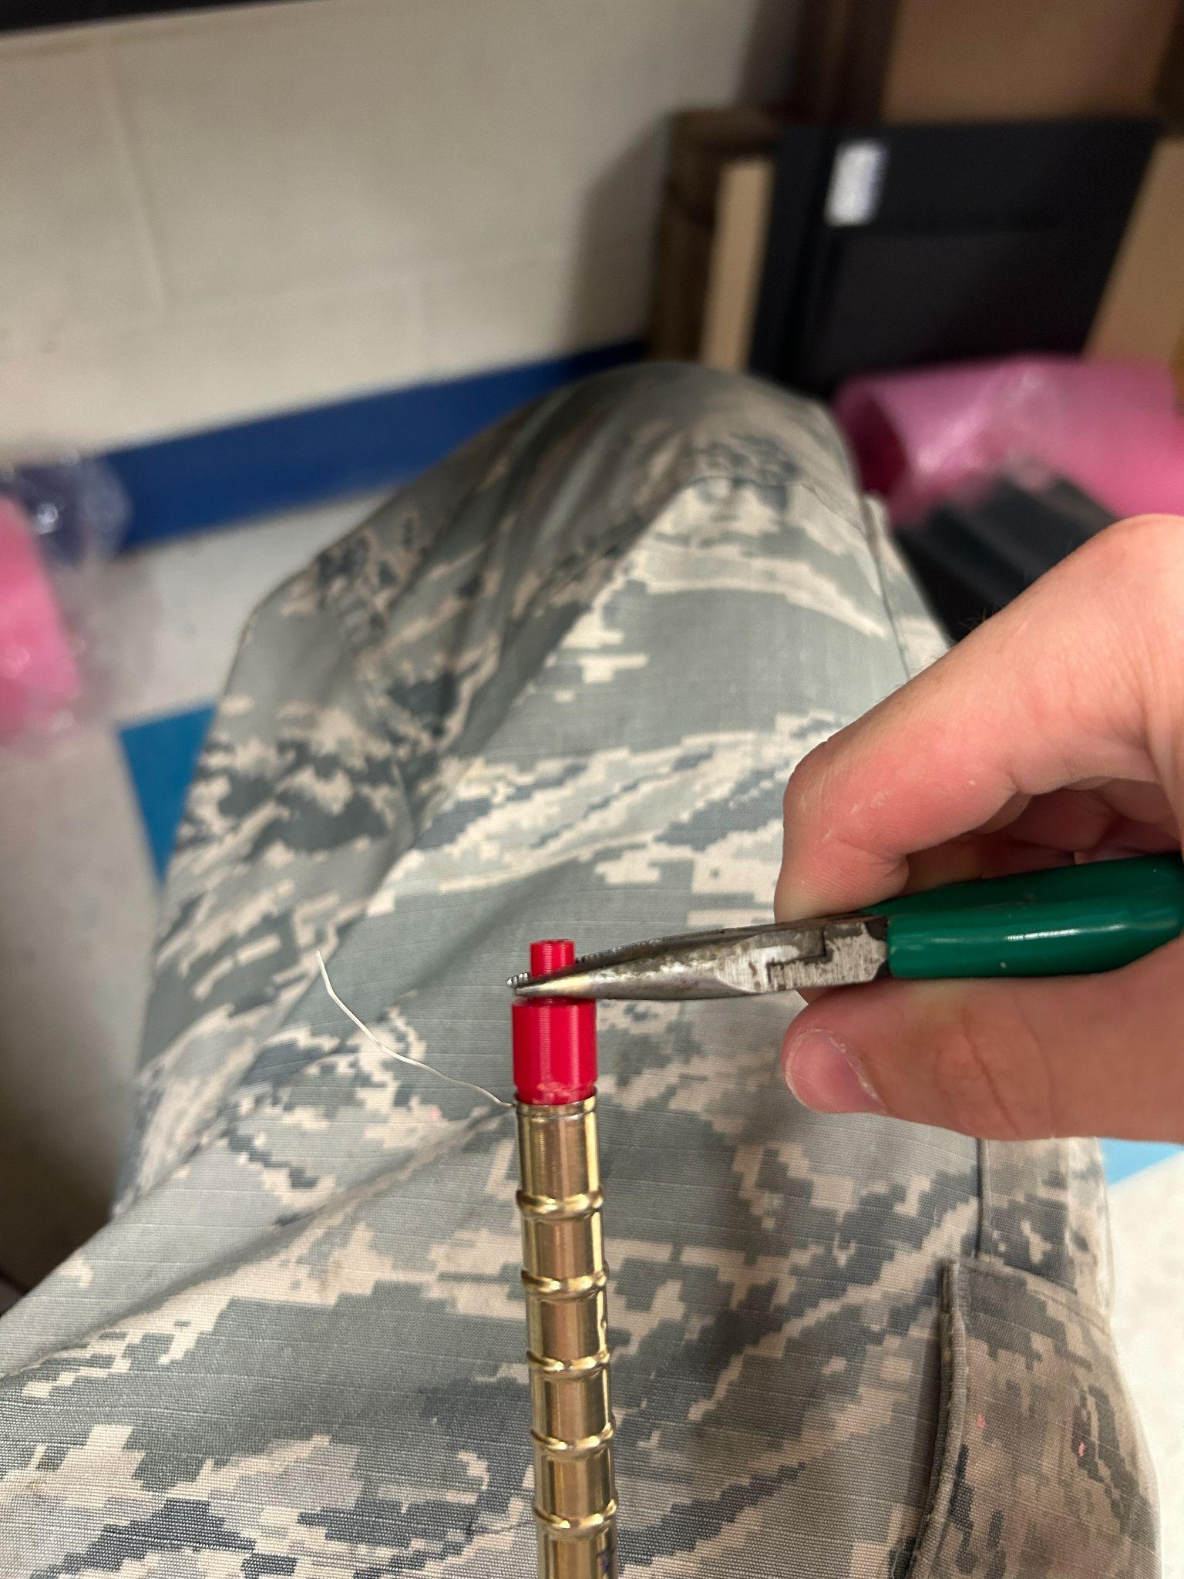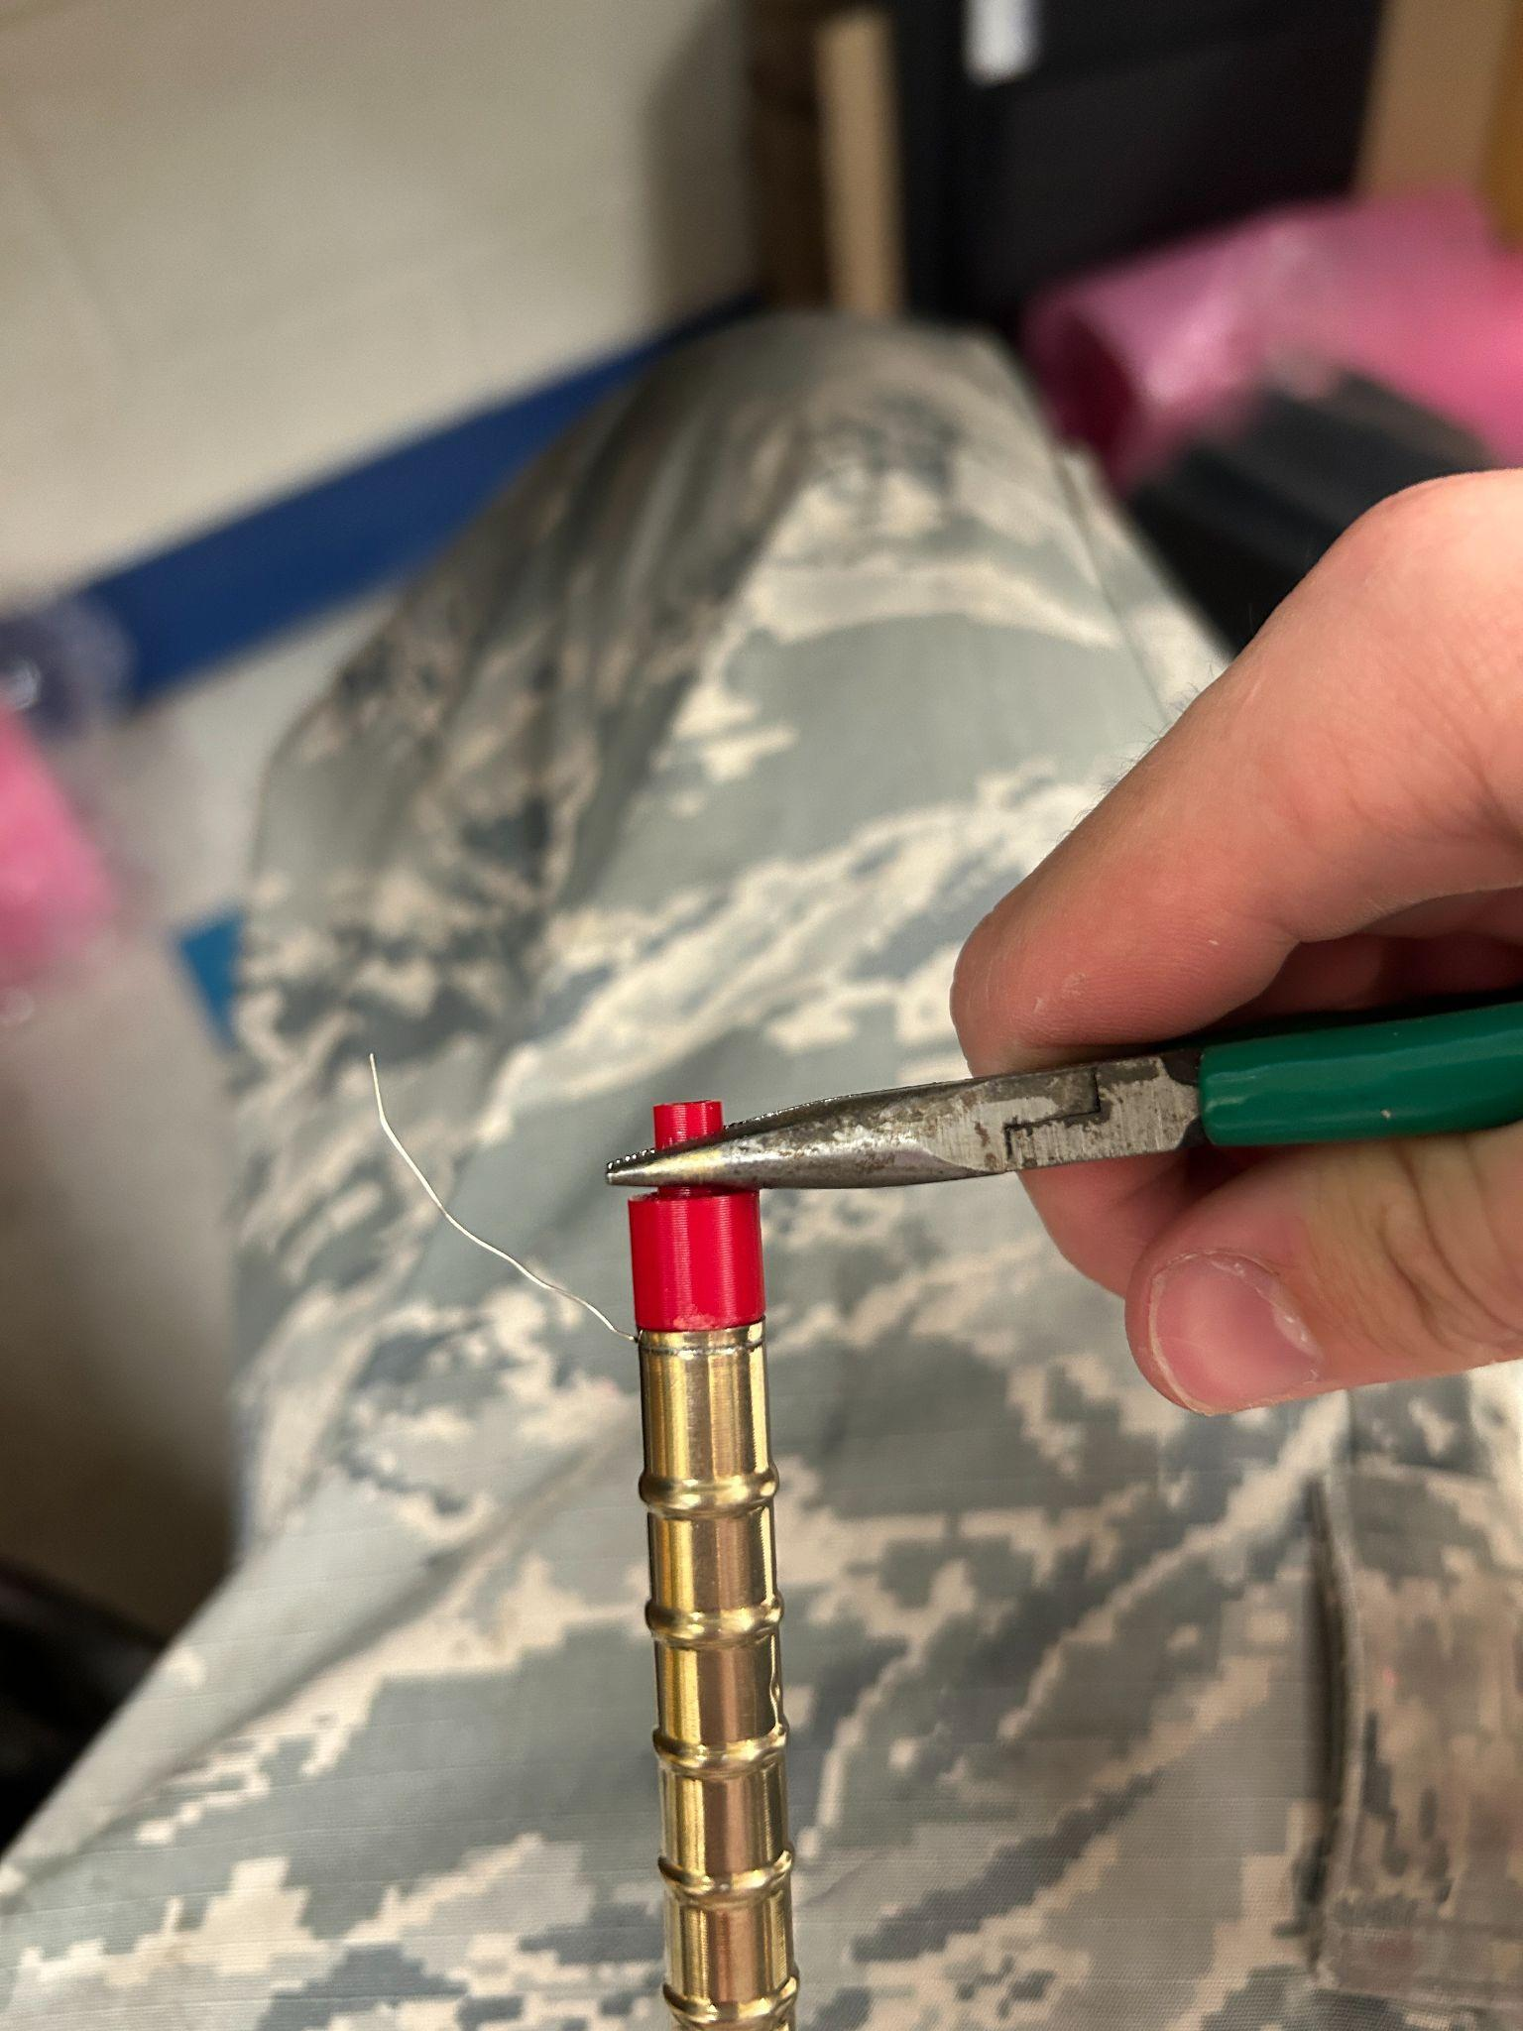

**STEP 5:**

Print another end cap (realistically just print like 16 of these things at a time and prep them ahead, both sides, although different, use the same end cap) and bore out the inside with a small screwdriver removing any excess filament that may have extended in the inside of the end cap.

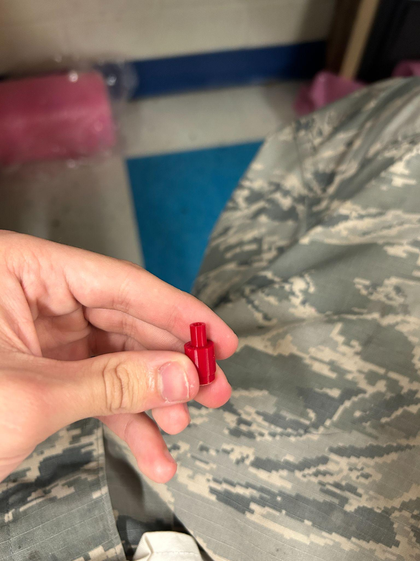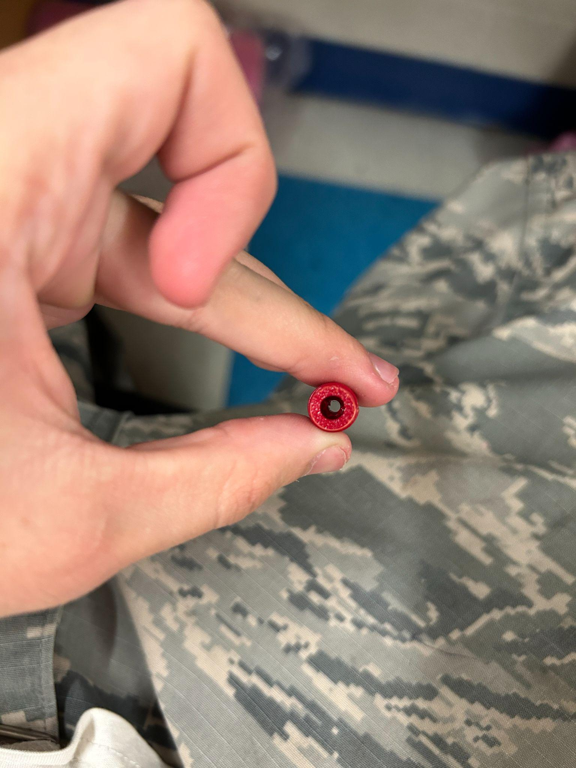

**STEP 6:**

Feed the wire and metal end (+) of the SBM-20-1 through the end cap and seat it with pliers just like the other side.

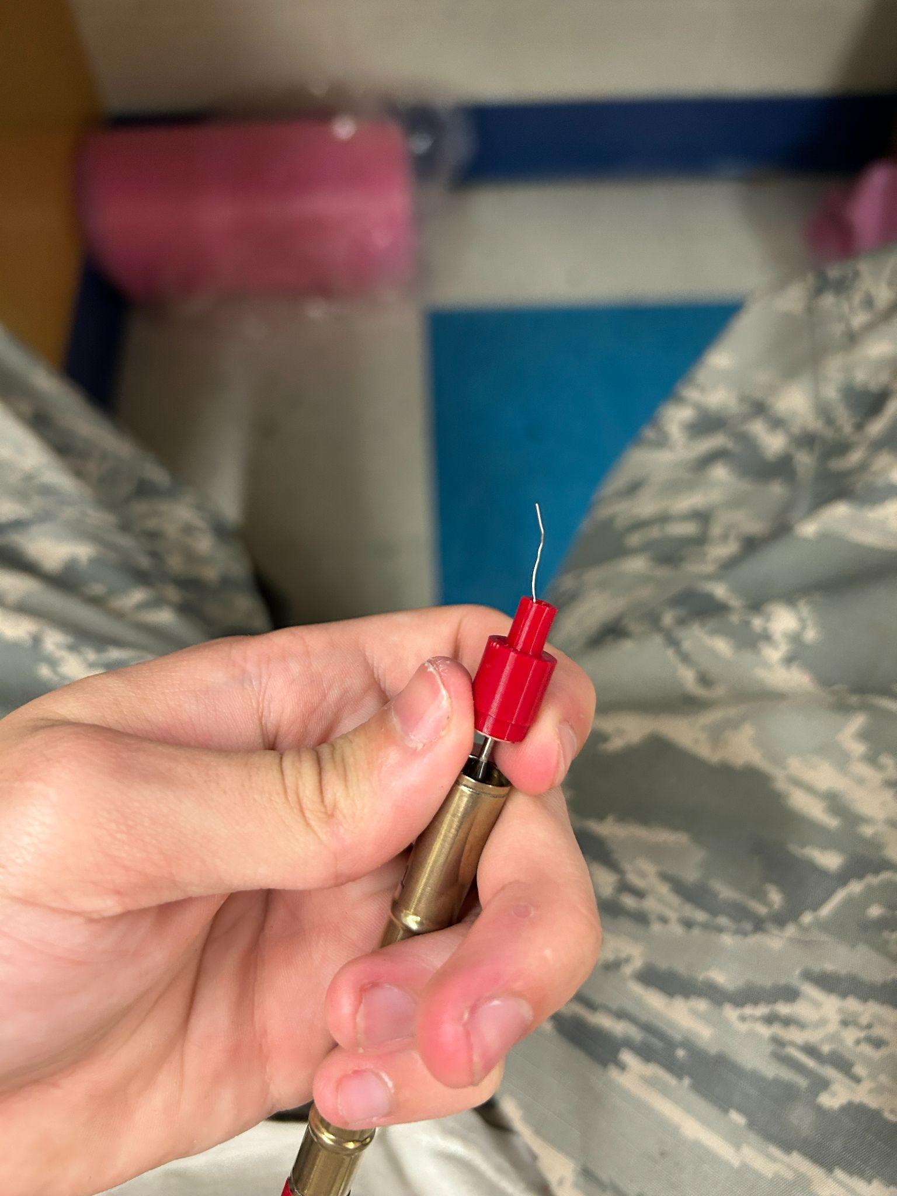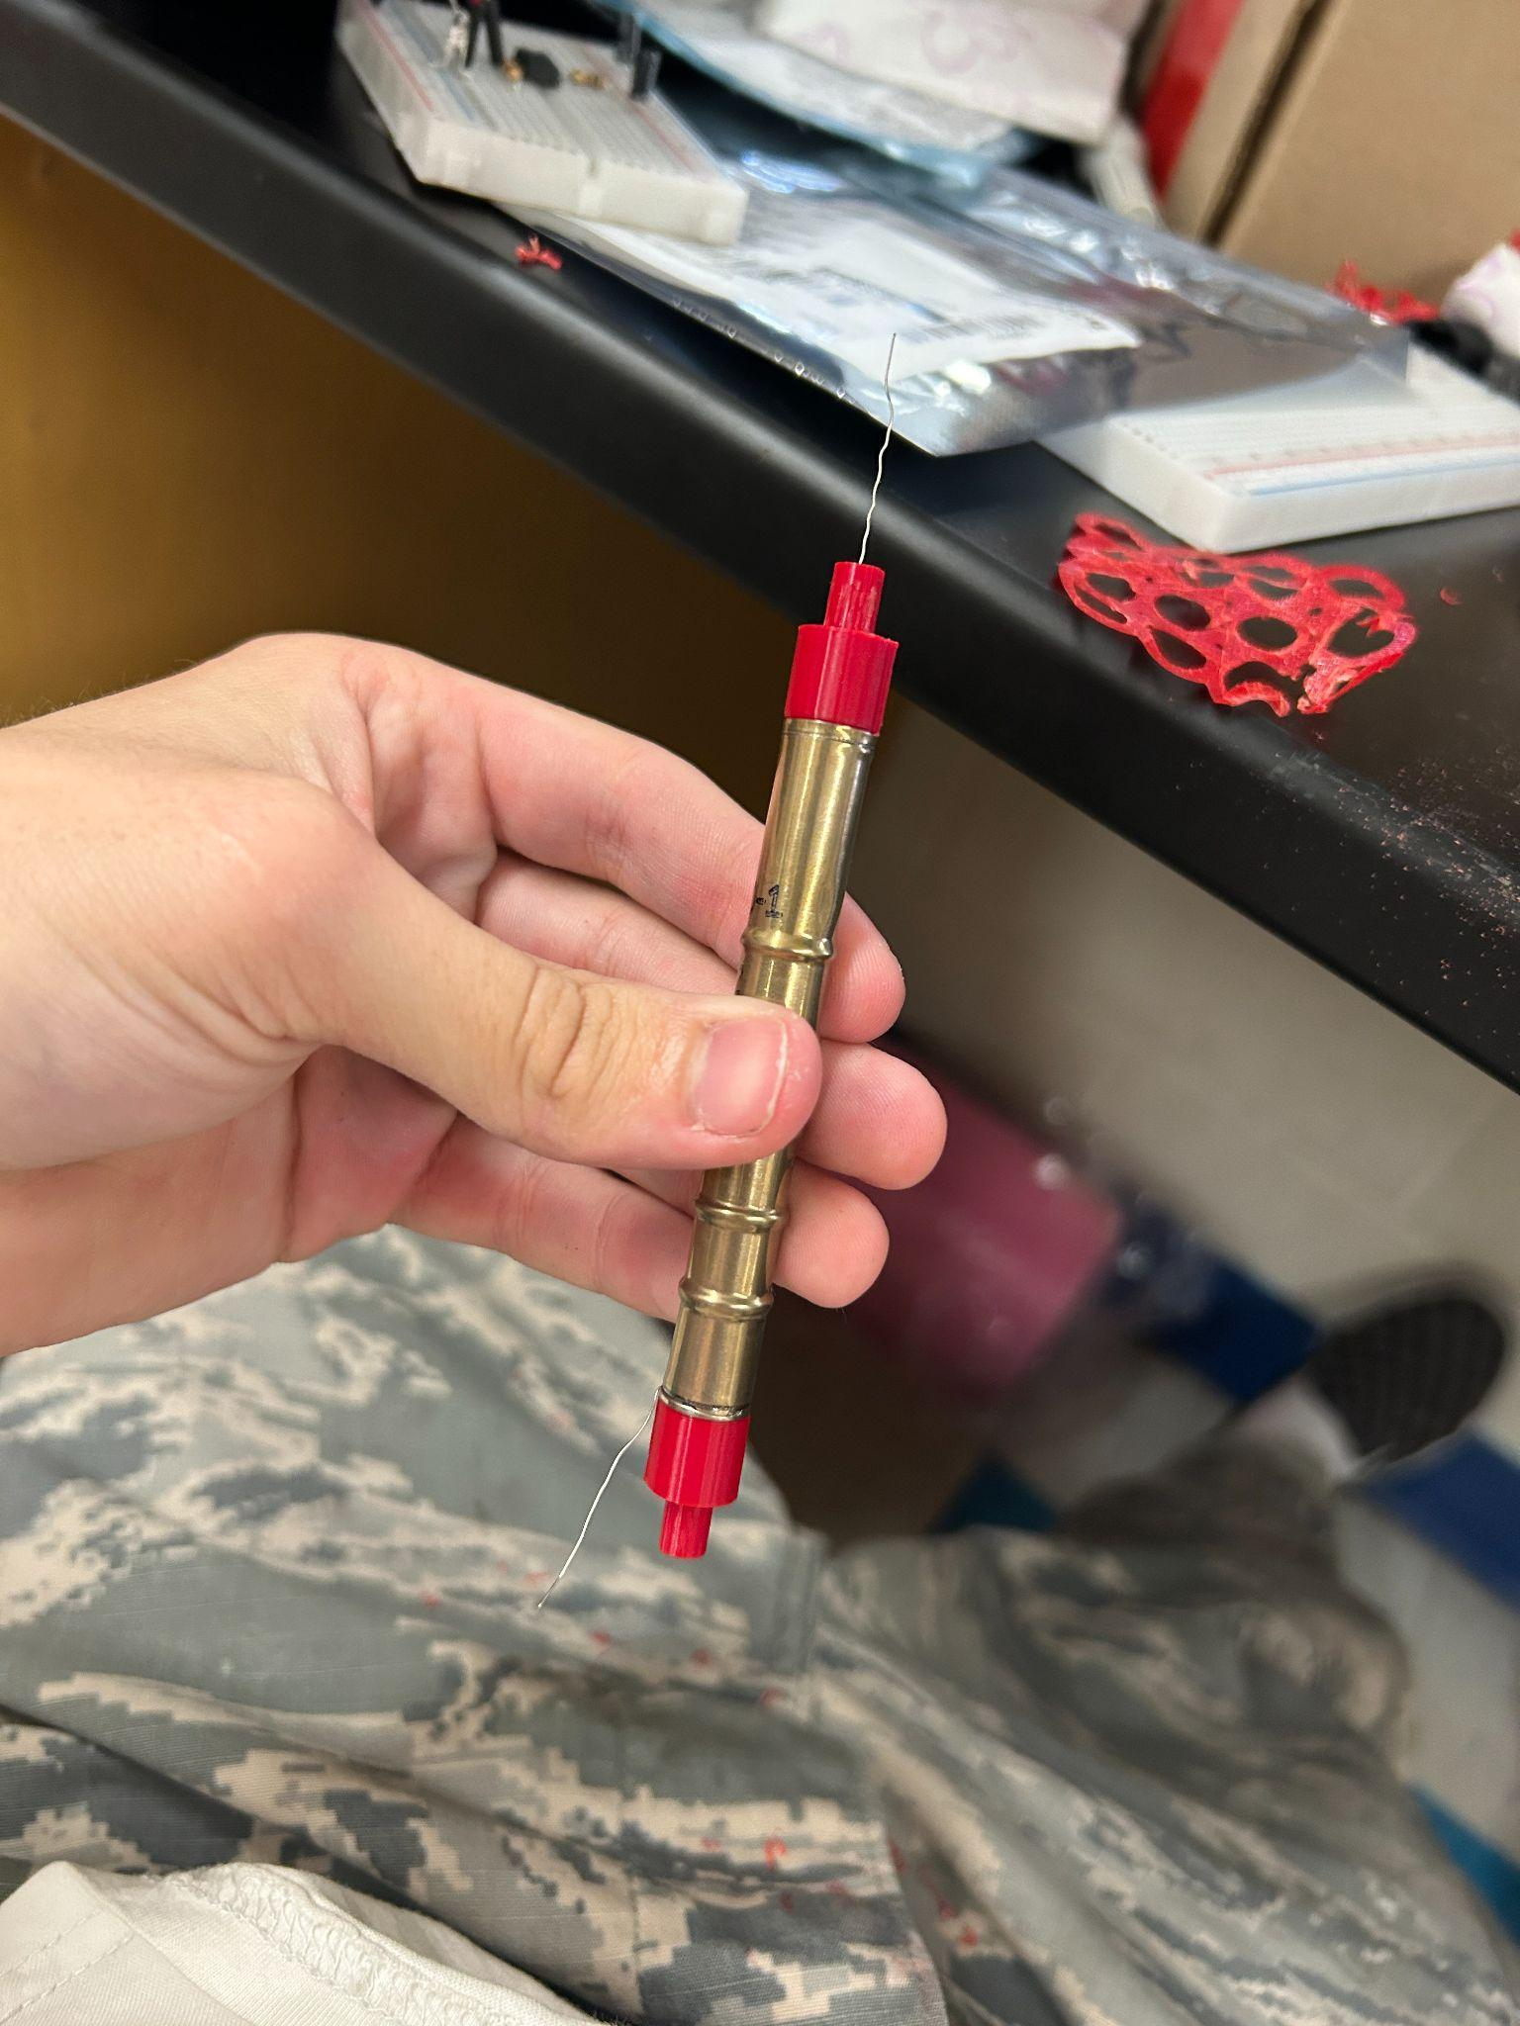

**STEP 7:**

Cut off a bit of the brass tube about the same length as the top part of the geiger tube ends. You may notice that this compresses the tube a bit. To combat this (and make the brass fit nicely) open the brass end up with the pliers and cut off another length of tube

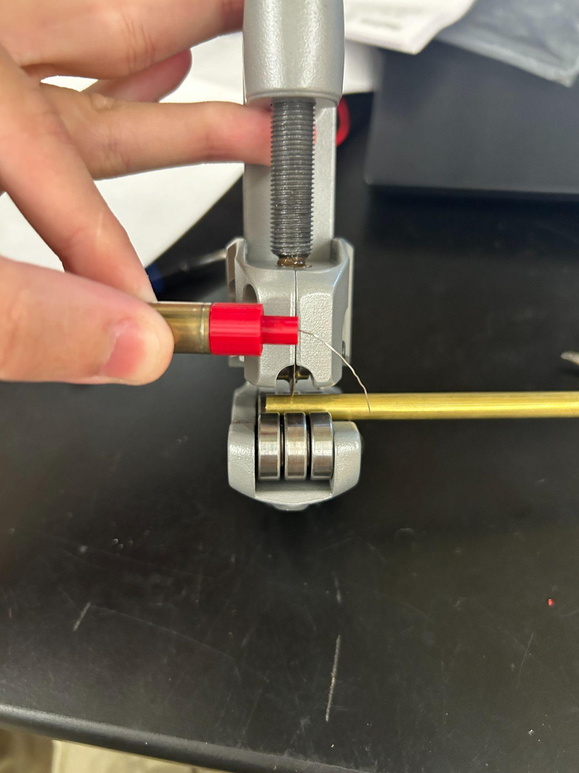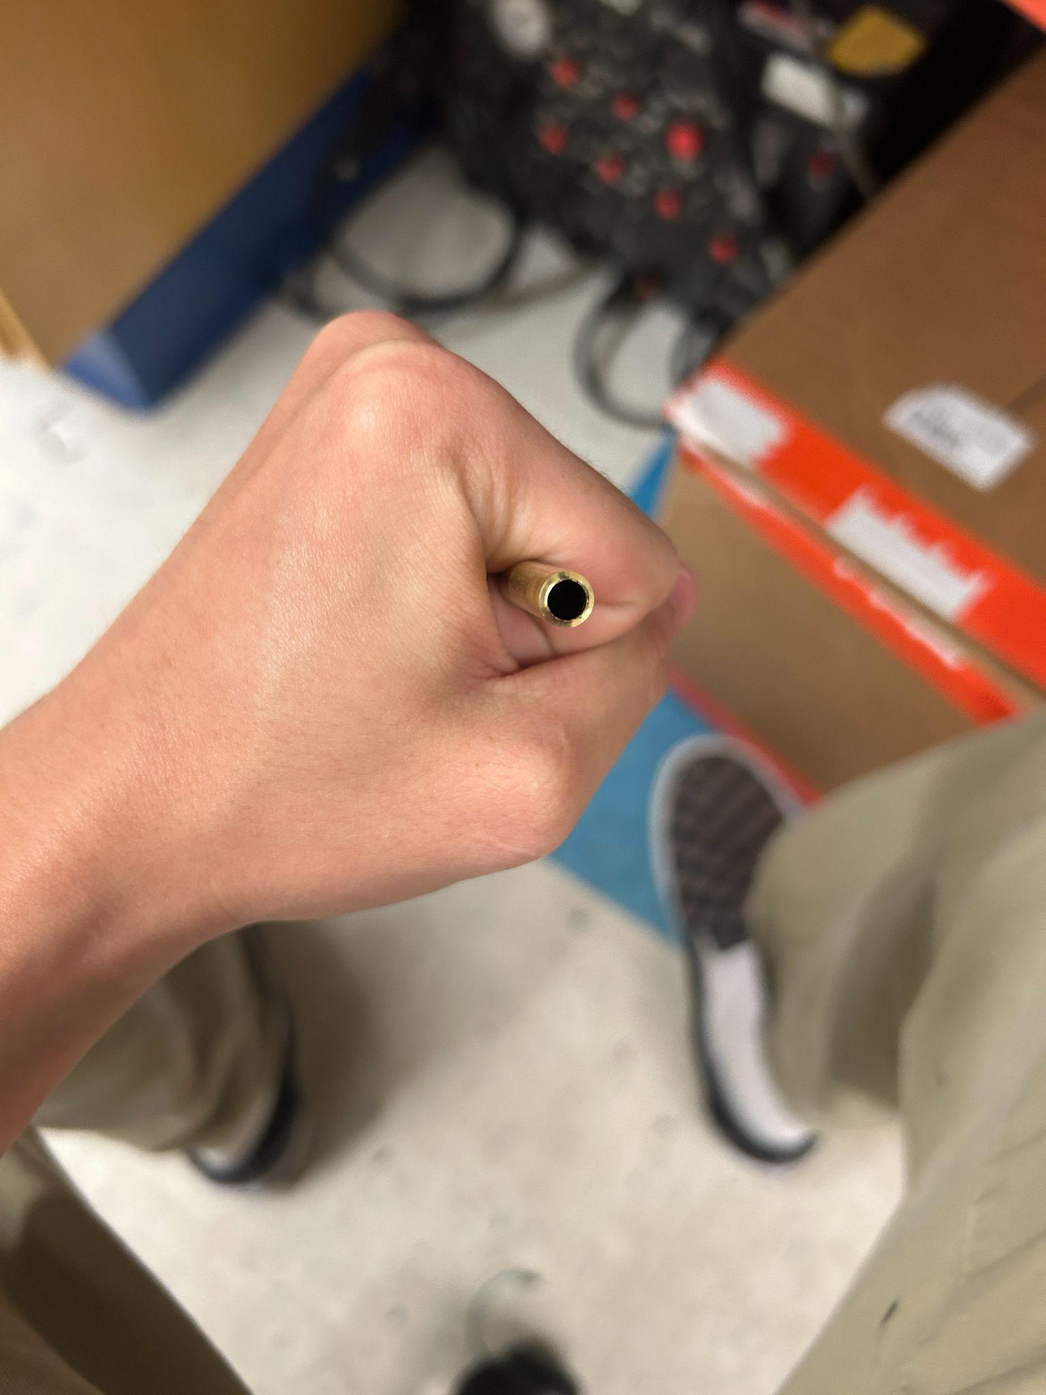

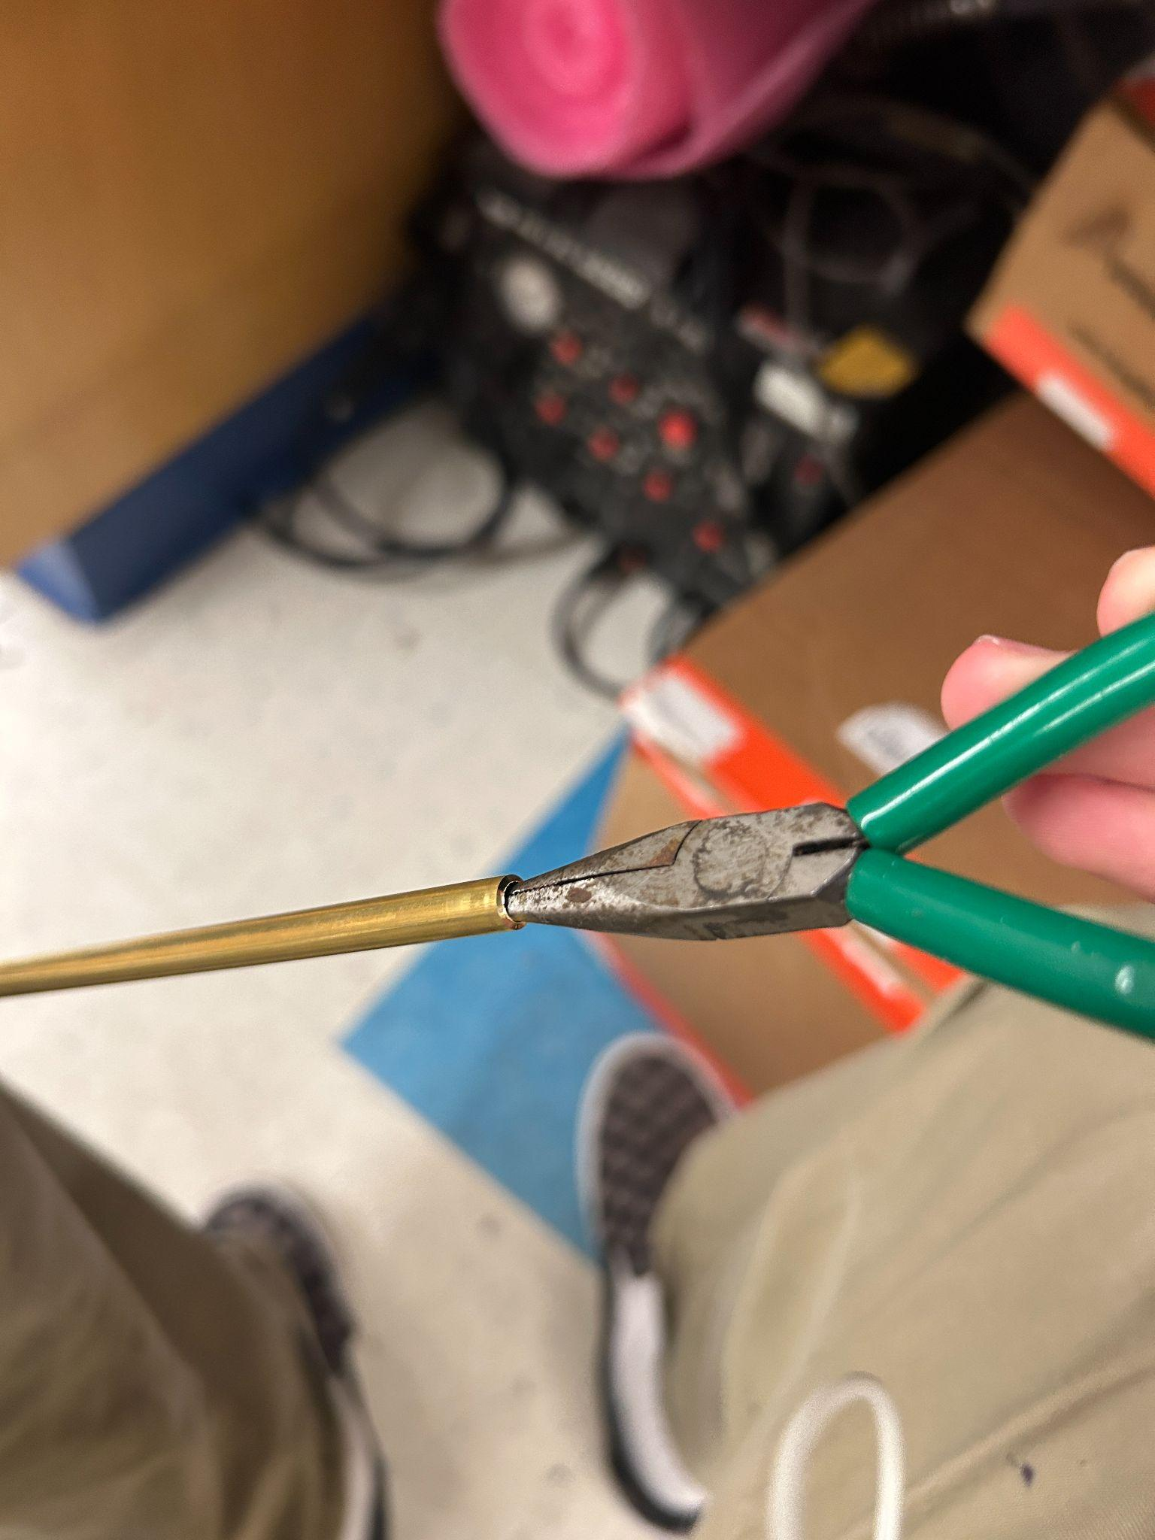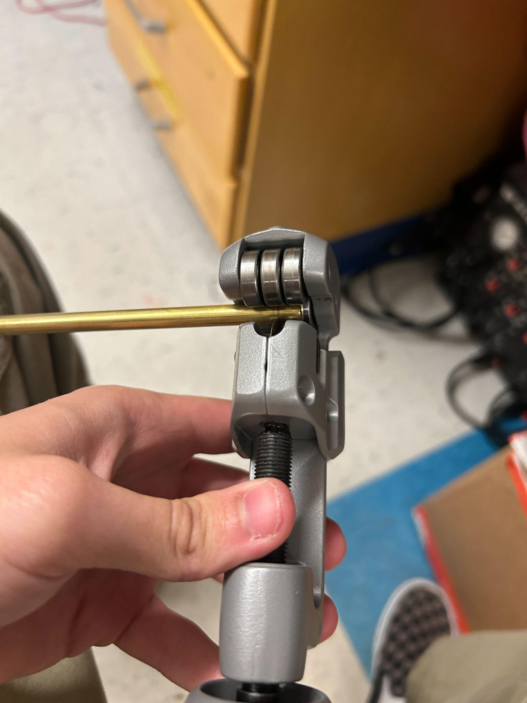

**STEP 8:**

If needed sand down around the top slightly for a better fitment of the brass tube, then on the positive side bend the wire down and fit the brass down with pliers, BE CAREFUL. It’s very easy to bend the tube at this stage. Once the brass tube is down, wrap the excess wire around the base of the small brass part we cut making sure that the wire does not come in contact with the metal body of the tube

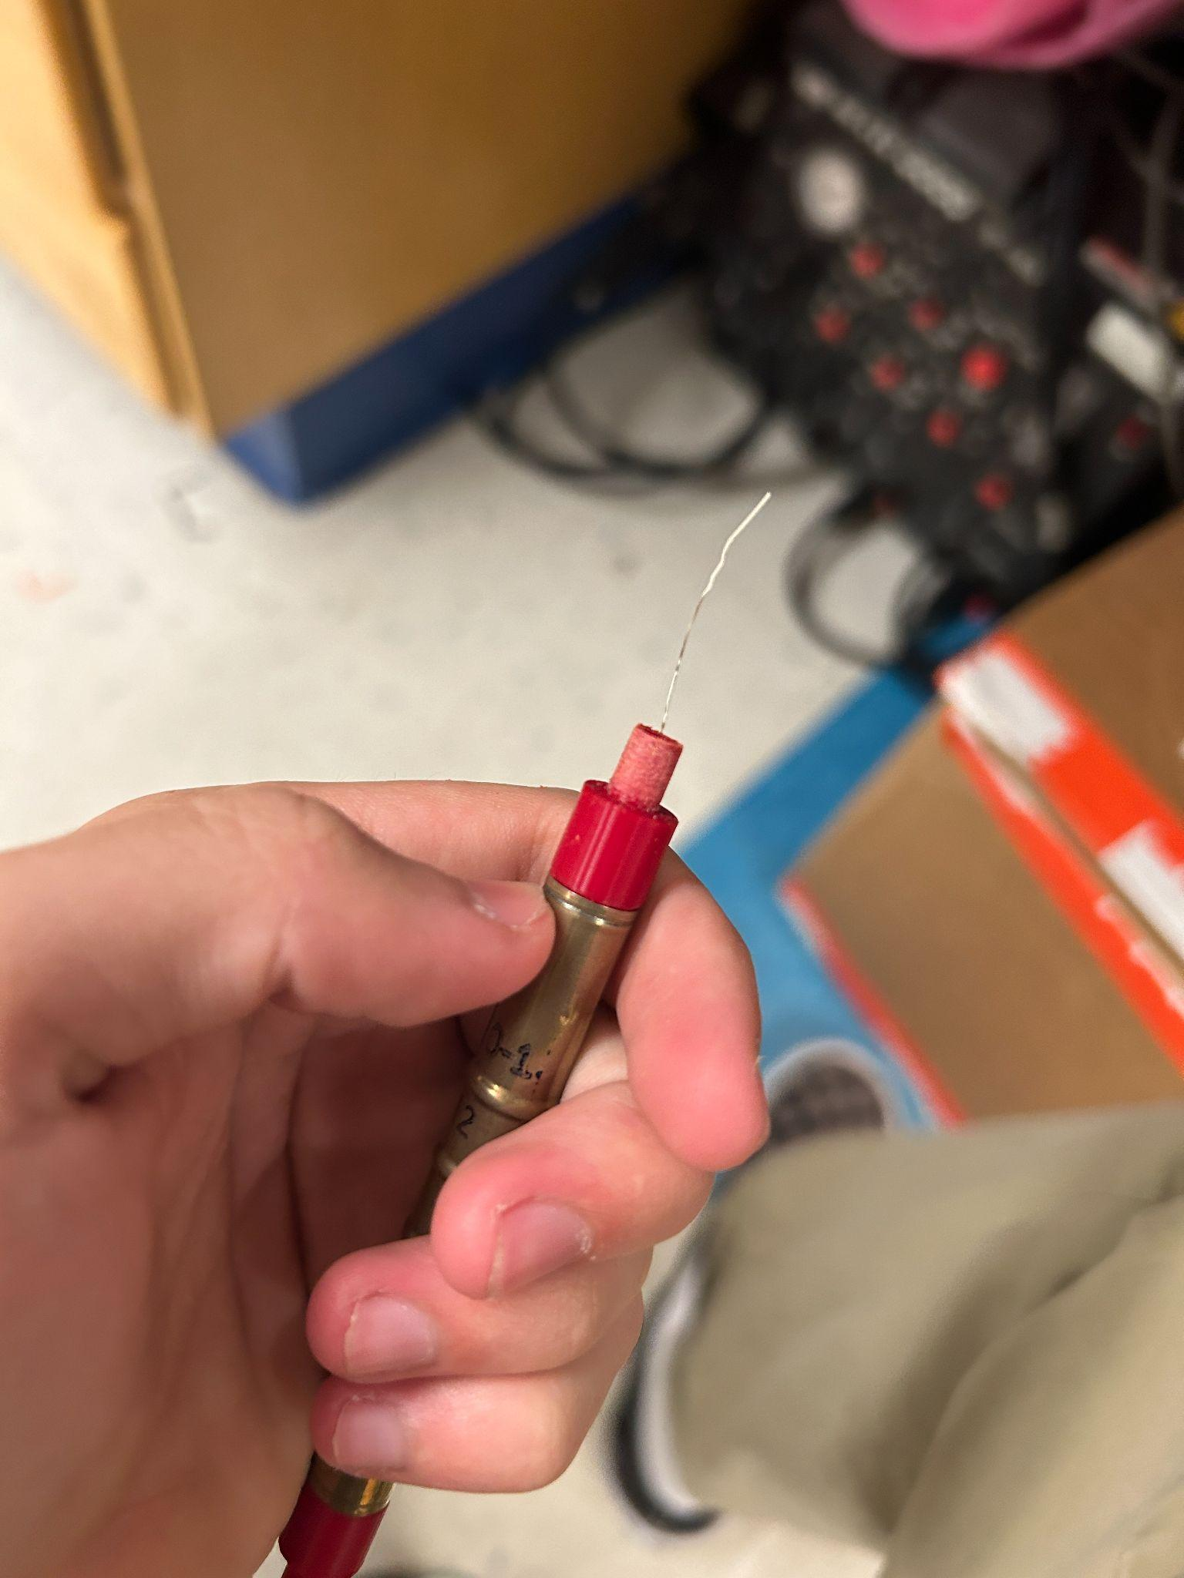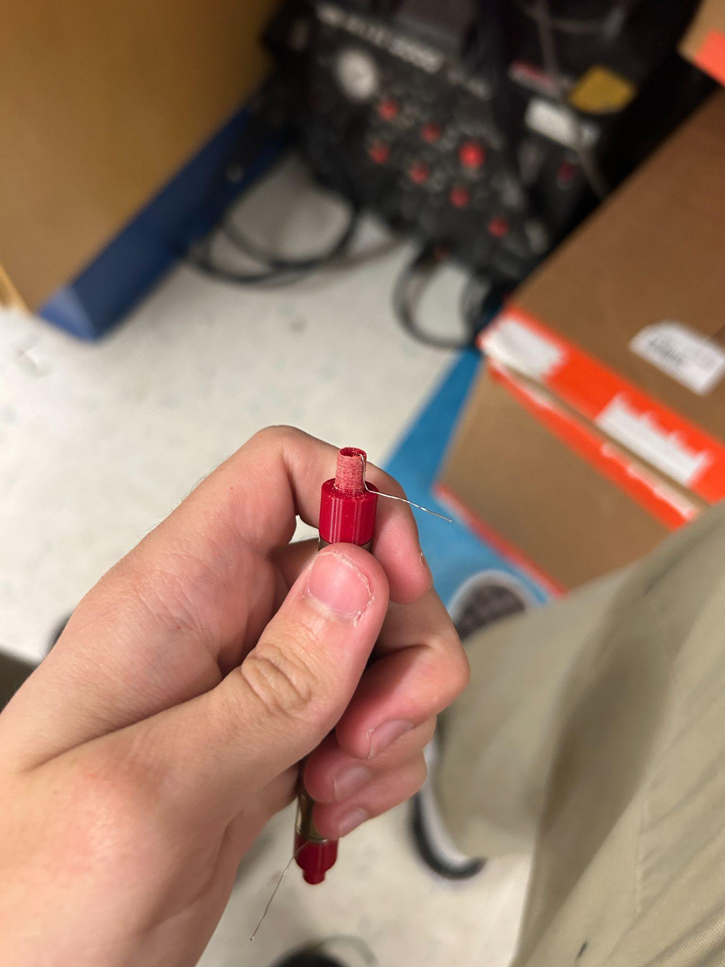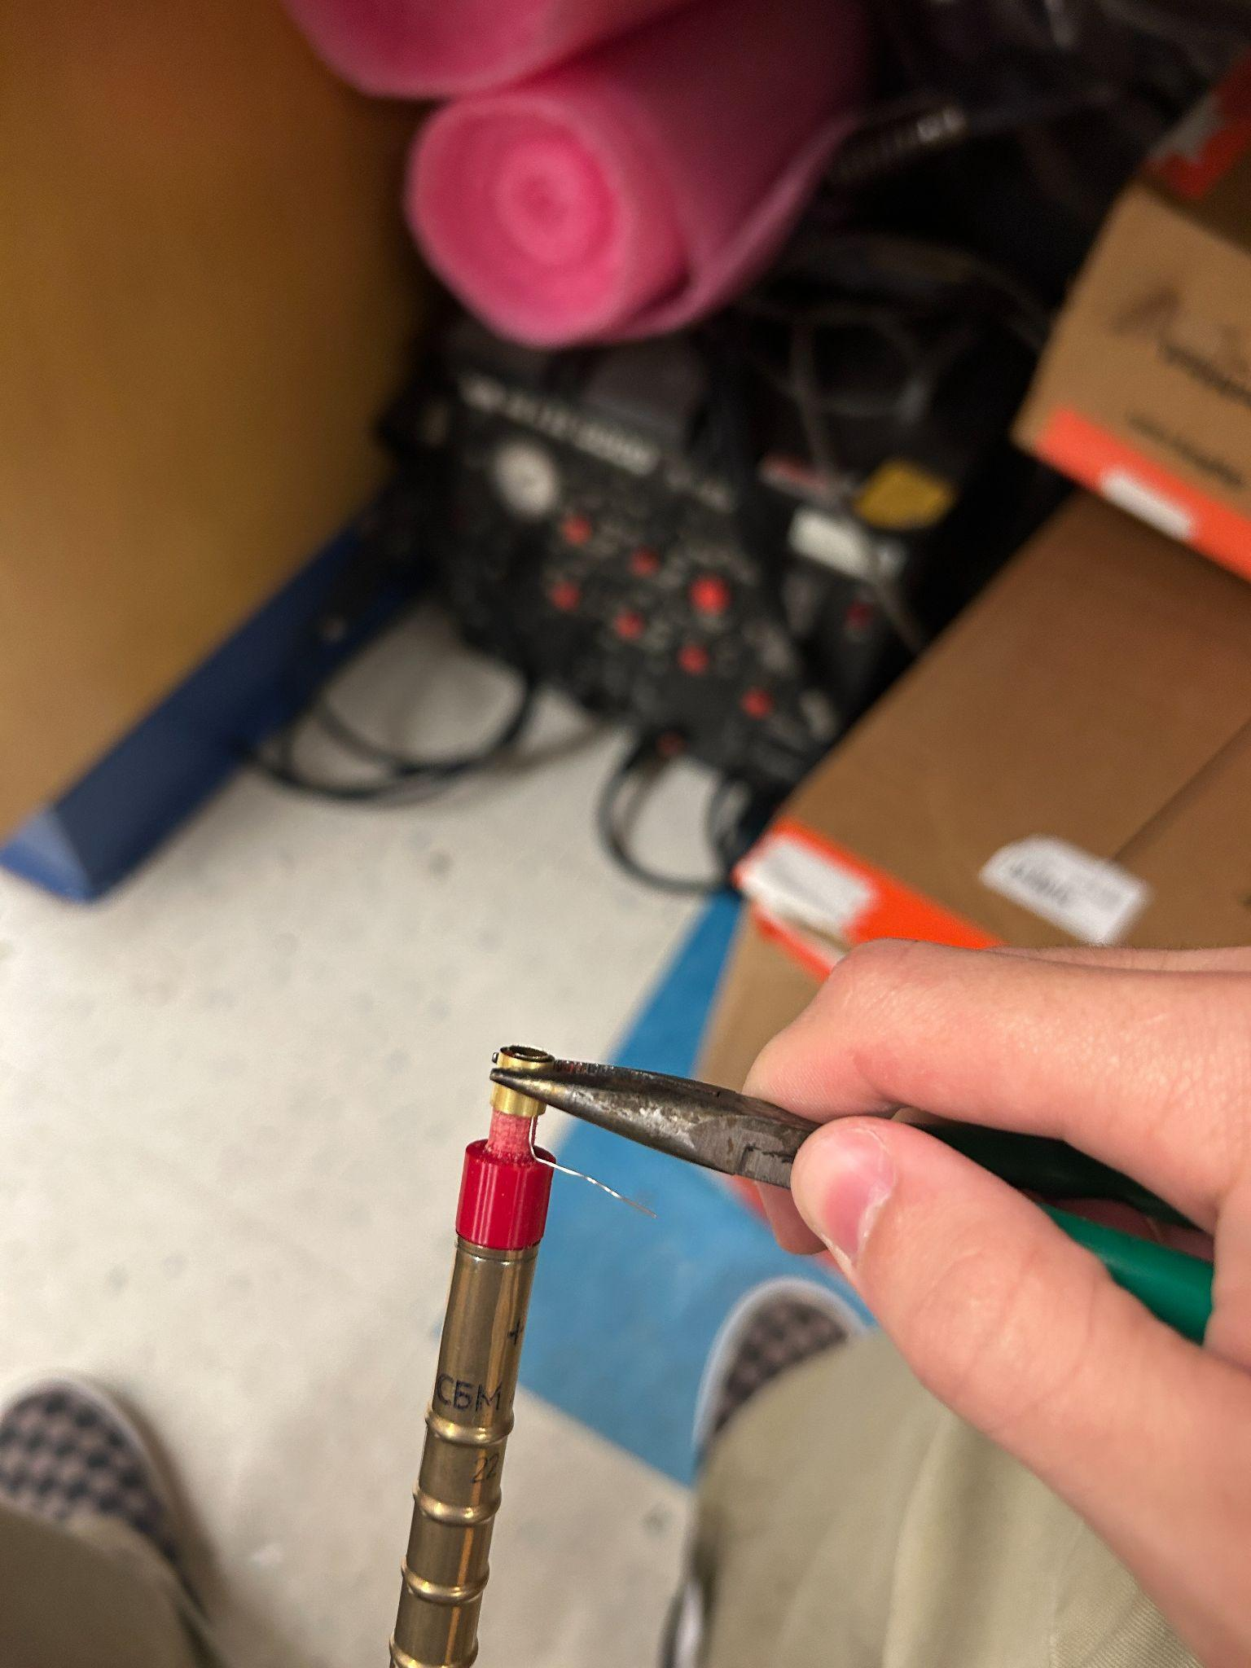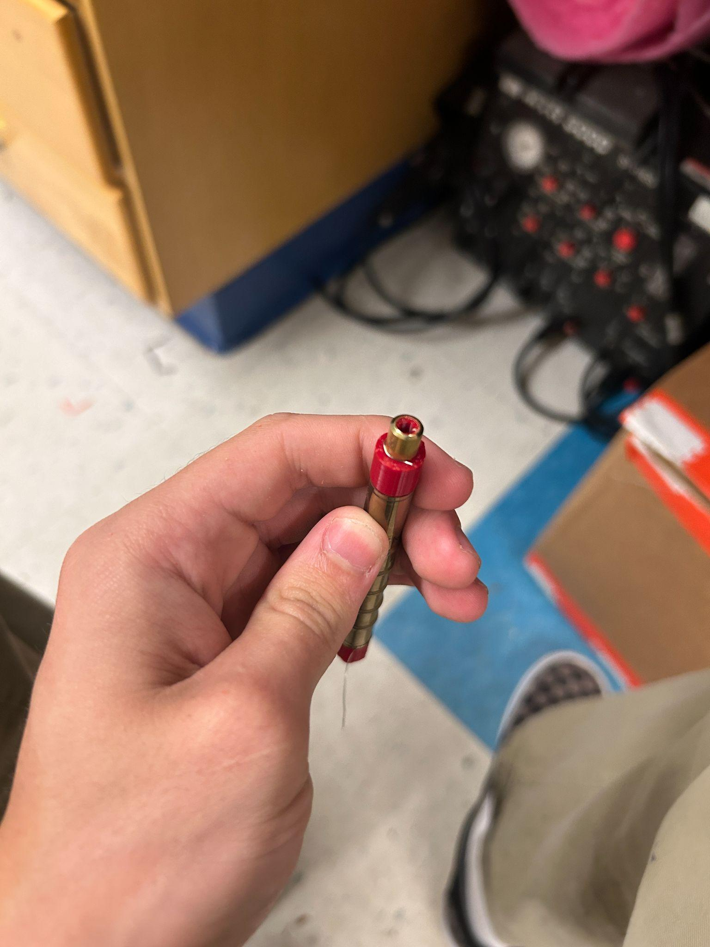

**STEP 9:**

Apply the same basic principles from the last step, but on the - side. Bend the wire up, and fit the brass around it

